Annual Performance &Quality Improvement Report

Period Covering
January 1, 2018-December 31, 2018

Prepared by the Performance and Quality Improvement Coordinator

January, 2019

Area IV Agency on Aging and Community Action Programs
Annual PQI Report
For Fiscal Year 2016

EXECUTIVE SUMMARY

In an effort to share important information regarding the quality of services and supports provided by Area IV Agency on Aging and Community Action Programs, the Annual Performance & Quality Improvement Report for fiscal year 2018 has been summarized. It derives its information from a wide variety of quality assurance systems and databases and is intended to be a starting point in the collective review and analysis of service quality. As such, it serves as one mechanism of determining where we are doing well as well as areas where improvements are needed.

Annual Performance & Quality Improvement Report for FY18

TABLE OF CONTENTS

Topic | Page
Executive Summary | 2
Table of Contents | 2
Listing of Charts and Tables | 3
Introduction | 4
Data Sources | 5
Strategic Plan Results | 6-13
Aging Area Plan Results | 14-16
Quarterly Case Record Review | 17-21
CAP Grantee Plan Results | 22-25
Risk Assessment, Safety & Wellness Committee Overview | 26
Board of Directors Self-Assessment Survey Results | 27
CAP Customer Satisfaction Survey Results | 28-32
Aging Client Satisfaction Survey Results | 33-37

Listing of Charts and Tables

TABLES
Table No. | Title | Page
1 | How Did You Hear About Us Client Satisfaction Results | 6
2 | Area IV Presentations | 7
3 | Contacts Made to People in Carroll, Clinton, and White Counties | 8
4 | Anthem Referrals | 9
5 | Medicaid Waiver Case File Review | 17
6 | CHOICE 2.0 Case File Review | 18
7 | Title III / SSBG Case File Review | 19
8 | Case File Content Compliance | 20-21
9 | ISTAR-KR Objectives | 23-24
10 | Board of Directors Self-Assessment Survey Results | 27
11 | CAP Customer Satisfaction Survey Results | 28-32
12 | Aging Client Satisfaction Survey Results | 23-37

Area IV Agency on Aging and Community Action Programs
Annual PQI Report
For Fiscal Year 2018

INTRODUCTION
On September 8th of 2015 the Area IV Agency on Aging and Community Action Programs Board of Directors and Senior Management began a strategic management planning process to develop and update a quality management and improvement system.
Strategic Priorities

- Increase public awareness and expand services to outlying counties
- Partner with care coordination organizations
- Maintain financial stability
- Maximize the potential of Senior Games
- Increase employee retention

Strategic Planning Retreat-Area IV Conference Room
Board of Directors and Senior Management
September 8, 2015, Tuesday, 10:00 A.M-3:30 P.M.

Present: Linda Sproull, Dianne Williams, Cindy Mason, Bob Brinson, Lisa Henry, Nelson Weaver, Robert Downing, Sandra Ruby, Anne Painter, Joretta Tinsman, David Rosenthal,
Absent: Randy Strasser, Hubert Shackleton, Jim Oliver
Also Present: Elva James, Julie Hackerd, Donna Collier, Joe Hemersbach, Chris Taylor, Judy Worland, Mary Paulsen

Colin Maiorano from Strategy Worx was introduced and led the Strategic Planning Retreat. The Management Team and Board of Directors reviewed area demographics, Area IV Agency Community Needs Assessment Report, the Alice Report, the Indiana University Health Arnett Hospital Community Needs Assessment, and Area IV’s Annual Report for 2014. The group present participated and was interactive throughout the planning session.

Mr. Maiorano presented strategies and discussed the development of the Area IV Strategic Plan. He discussed tangential expansion, opportunities, participation, the creation of hypothesis, De-Risking of potential program expansion, use of media, donors, and other interested parties. Small group work was done under the lead of Mr. Maiorano. The planning results were assembled and presented to the Board of Directors for approval on December 8th, 2015.

DATA SOURCES
The P.Q.I. report derives its information from a wide variety of different sources, including:

Strategic Priorities Logic Model
Aging Area Plan Goals
INSITE Reports
CAP Grantee Plan Goals
CAPTAIN Reports
Human Resources Reports
Client Satisfaction Surveys
Outreach and Presentation Reports
IRIS Reports
Senior Games Surveys
Recruitment and Retention Report
Staff Survey Results
Quarterly Case Record Reviews
Fiscal Reports
Quarterly CAP Reports
ISTAR-KR Reports
Risk Management, Safety and Wellness Reports
Board of Directors Self-Assessment Surveys

STRATEGIC PLAN

OUTCOME: Increase Public Awareness and Expand Services to Outlying Counties
Activities:
1. Update program flyers
2. Add question - "How did you hear about us?" to our client survey
3. Canvas communities with brochures especially Clinton, Carroll and White Counties
4. Staff attend/present at community meetings
5. Expand the Energy Assistance Program into Boone County

RESULTS:

- Agency brochures and program flyers were updated during the first quarter.
- The question “How did you hear about us?” was added to our client satisfaction survey.
- Increased attendance at Health Fairs and Community Resource Meetings.
- Increased presentations about Area IV Services.
- Increased contacts to clients in Carroll, Clinton, and White Counties
- Through the ADRC reinvigoration grant, 18 MOUs have been maintained.
- 5,000 Area IV Agency Quarterly Newsletters were sent out.

Chart 1
Client Satisfaction Surveys Results for:

Chart 2
Area IV Presentations

Chart 3
Contacts made to people in Carroll, Clinton, and White Counties

STRATEGIC PLAN

OUTCOME: Partner with care coordination organizations
Activities:
1. Build relationships with insurance companies like Anthem for care coordination
2. Develop resources for our counties to deliver to potential partners
3. Present to providers about services we deliver
4. Send information newsletters to potential partners

RESULTS:
- Aging completed work on the ADRC Reinvigoration Grant which focused on expanding partnerships in outlying counties; 45 agencies were contacted with 18 returning MOUs.
- The Aging Advisory Council membership was examined and several new members were brought into the counsel so that counties were better represented.
- Area IV applied and was approved for a $25,000 Ramp-Up Indiana grant that provides wheelchair ramps to low-income homeowners that lack accessibility.
- Area IV continues to work with Anthem for care coordination referrals, are accepting clients for Money Follows the Person (MFP), and had taken on a Private Pay Client.

Chart 4
Anthem Referrals

STRATEGIC PLAN

OUTCOME: Maintain financial stability

Activities:
1. Implement a paperless policy across the agency
2. Research and apply for grants especially for unrestricted funds
3. Receive donations through fundraiser activities
4. Increase revenue through partnerships

RESULTS:
- The donor lists have been revised to better target for donations and donation request letters have been sent out.
- Area IV received several small grants this year to supplement programming.
- All current grants have been renewed.
- Revenue has increased through Area IV Development which will benefit Area IV Agency.
- Staples completed a Cost Analysis of printing and supply costs and now Area IV uses the Staples Business Advantage Program.

STRATEGIC PLAN

OUTCOME: Increase employee retention

Activities:
1. Implement a cross-training program
2. Complete a wage comparison study for staff
3. Complete succession plans
4. Provide COLA and merit increase
5. Improve supervisor training

RESULTS:
- Cross training of all Aging supervisors has been completed
- Current succession plans are in the process of being reviewed and updated
- The retirement plan continues to do well and staff were given a retirement presentation by Voya representatives in August 2018
- Teladoc continues to be utilized by staff and per Teladoc there was a savings of $22,258 in 2018
- 2018 Employee survey was completed and reviewed for any areas of improvement
- Wages were reviewed and employees received performance/merit increases in July 2018
- Area IV completed supervisory and All Staff trainings periodically throughout the year.

Retention and Turnover:
Area IV had 58 employees as of January 1 and 55 employees as of Nov. 30.
Retention of those employed as of January 1, 2018 and remain employed is 88%
Turnover of those employees who left the Agency for other employment is 8.4%
The current average tenure of Area IV employees is 10 years.

Employee Turnover by Type:
Took Another Job (5)
Retired (0)
Relocated (2)
Resigned (no new position) (1)
Terminated by Agency (1)
Position Eliminated by Agency (0)

Recruitment:
The Agency has been utilizing its own website, Indeed.com and Indiana Career Connect to place job ads. The Agency is able to post jobs for free on these sites. There is also an option on Indeed.com to pay to have premium postings on the website if this becomes a need. The Agency has recently utilized the premium posting option for available Care Management and Assessment and Transitions Specialist positions in the Aging Dept. as these positions have been difficult to fill. Given the current job market, the Agency has had some difficulty recruiting for positions that require very specific degrees and/or work experience. The EAP dept. saw an increase in hiring this fall when several temporary/seasonal staff were hired. There have been some staffing changes in the Aging Dept. including the resignation of Deputy Director Joe Hemersbach. The Agency has been able to fill this position as well as others through promotion and realignment of current staff.

AGING AREA PLAN
GOAL: Improving access to services through successful implementation of the Community Living Program (CLP) into our case management services, improving efficiency in the use of resources and better addressing client needs.

PROGRESS:
- The Area IV Aging Program participated in the CLP or CHOICE2.0 pilot project, which has been expanded to the entire state.
- Area IV has participated in CAMSS training. CAMSS will be replacing INSITE and is expected to be fully implemented in the spring of 2019.
- Wait List was reduced during 2018.
- Participated in the statewide development of the INconnect Alliance branding campaign, which exists to educate the public about AAA services.
- MOUs have been signed with 15 partnering organizations in the region in the past year.

AGING AREA PLAN
GOAL: Increase the availability of transportation in Tippecanoe County

PROGRESS:
- Efforts were made to identify specific populations in need and there was no one target group for this service. After several attempts to find vendors, Area IV was unable to successfully recruit a Title III provider. There are numerous transportation services in the area receiving funding from other sources, including private funding. This service may not be possible to support at this time.

AGING AREA PLAN
GOAL: Develop a region-wide volunteer program to match volunteers to clients.

PROGRESS:
- The Volunteer Program was put into hiatus due to a steep decline in volunteer participation and the retirement of the program coordinator. Area IV will revisit the possibility of restarting this program at a later date.

QUARTERLY CASE RECORD REVIEW
Chart 5
MEDICAID WAIVER CASE FILES

Chart 6
CHOICE 2.0 CASE FILES

Chart 7
TITLE III / SOCIAL SERVICE BLOCK GRANT CASE FILES

Chart 8
ALL CASE FILES CONTENT COMPLIANCE

Key Findings and Recommendations:
- Out of 88 files, 10 had something marked as incomplete or untimely, which is approximately 11% of all files. This is a great improvement over last year.
- Timeliness is improving with client files, but there is still room for improvement. And there should continue to be strong emphasis on completing assessments on time.
Next Steps:
- The Outcome Reporting Form that has been updated for 2018 includes a section for scheduling the next 90-day review with the client. The use of this section will be regularly monitored to ensure that staff are scheduling their client’s next review to prevent late assessments.
- Clinical Supervision should continue to focus on the timeliness of staff’s work and review files to ensure completeness.
New employees are given initial training regarding expected documentation in the case notes. Documentation in case notes training will be ongoing for all aging staff.

CAP GRANTEE PLAN
GOALS: #1 - Increase awareness for individuals and families to increase program participation of families in poverty in all CAP programs
#2 - Increase the opportunities between Area IV Agency and community-wide partnerships to provide services to the vulnerable population
#3 - Broaden the resource base between Area IV Agency and community resources to enable increased capacity of services
#4 - Provide high quality child care at the Park Place Learning Center and Woodlawn Preschool in Monticello, IN due to community need in White County

PROGRESS:
- BEED – Decreased to 4 active loans in 2018 from 6 active loans.
- Energy Assistance Program
  - Outreach through mailings, Facebook, contacting previous clients, attending social service meetings (7 counties), HPC, HPIN, holding meetings at low-income apartments complexes and handing out applications at mobile food pantries; visited other agencies to gain insight and compare methods
  - 8,648 applications were completed as of 12/31/18 compared to 1,786 taken last year at this same time (number is up by 6,862 households); numbers may reflect colder weather and the program expansion into Hamilton and Hendricks Counties in addition to Boone, Carroll, Clinton, Tippecanoe and White Counties. The return to RIAA decreased delays in processing applications.
- Housing Choice Voucher Program
  - Added new property owners/landlords throughout 2018 in an effort to increase participation
  - Numbers have decreased and the program has around 210 clients compared to 221 in 2017.
- Individual Development Accounts
  - Marketing has taken place with the Organizational Payee Program, Energy Assistance Program and the Housing Choice Voucher Program participants as well as presentations at low-income apartment complexes; we currently have 7 active participants in 2018 from 6 active participants.
  - All 7 participants are active (inactive clients were removed)
- Organizational Payee Program
  - Increased outreach yielded an increase in applicants; mailed brochures to home health care agencies, networked at community social service meetings in our area, provided information at HPIN meetings and gave presentations at low-income apartment complexes.
  - Numbers have remain at approximately 126 per month compared to 2017.
- Park Place Learning Center
  - PPLC maintained its partnership with Monticello City Parks and is nearly at full capacity
  - Area IV received a White County Community Foundation grant to provide match for the Early Education Matching Grant; the EEMG has allowed for the Learning Center to partner with IU collaborating with FSSA to complete assessments and outcomes for the grant children
  - Area IV received a collaborative grant from 21st Century Learning Centers in a partnership with Twin Lakes School Corp and The Boys and Girls Club; the Women's Giving Together Fund also granted funds toward the match needed
  - Assessment on the following objectives occurs three times per year on all children. Children are making progress in all areas at this time.
- Transportation
  - Marketing of all CAP included presentations at community transportation quarterly board meetings
  - HOPE Transit provided 989 one-way ride during 2018; Rural Volunteer Transportation made 4,623 trips during 2018; these numbers are holding steady over time and allow individuals to remain independent in rural communities
- Weatherization
  - Providing Increased awareness of the weatherization program to EAP staff have allowed them to better inform clients of the program
  - YTD completions for 2018 were 130 compared to 124 during 2017; which is a 5% increase from 2017.

Chart 9
ISTAR-KR Objectives
English/Language Arts | Mathematics | Personal Care Skills | Physical Skills | Social Emotional Skills
Comprehends details | Computation (understand addition as putting together and adding to, and understand subtraction as taking apart and taking from); | Oral Motor | Sensory Integration | Sense of Self and Others
Events and main ideas (stories, novels, drama, poetry); | Counting and Quantity (number names, count objects, understand place e.g. value of 10 ones in the number 10); | Self-Feeding | Physical Stability | Manages Emotions;
Uses print for pleasure and information (range of texts); | Length, Capacity, Weight, Temperature (describe and compare measureable attributes); | Dressing/Undressing | Gross Motor Skills | Interpersonal Skills;
Writing for a specific purpose and audience | Location (describe objects in terms of placement); | Care of hands, face, nose | Object Control | Responsibility
Uses writing implements (uppercase, lowercase, punctuation, capitalization); | Sorting and Classifying Objects (classify objects and count attributes of objects); | Toileting | Precision Hand Skills | Problem Solving; Learning
Demonstrates expressive language (acquisition and use of vocabulary); | Time (understand time in relation to events; sequence events; use measuring units of time)
Demonstrates receptive language (comprehend and collaborate);
Demonstrates awareness of sounds (phonological understanding);
Demonstrates awareness of symbols (print concepts, phonics, word recognition)

CAP GRANTEE PLAN
GOALS: #5 - Improve the conditions where people live through community improvement and revitalization
PROGRESS:
- Housing Development
  - Awarded the Moving Forward 2.0 grant with a new partner, RealAmerica. This innovative housing concept will incorporate transportation with other energy supportive systems using a holistic approach to move families to self-sufficiency; after reviewing the Otterbein Commons project, a decision was made to resubmit this project during 2017.

Moving Forward Program Takes on New Challenge
INDIANAPOLIS (April 30, 2018) – The Indiana Housing and Community Development Authority (IHCDA) announced today plans for the Moving Forward Rural Development (RD) program. Using the Moving Forward model developed in 2015, IHCDA in partnership with Energy Systems Network (ESN) will take on the challenge to preserve a minimum of 30 USDA Rural Development (RD) properties at risk of losing their affordability by 2020.
“The purpose of Moving Forward Rural Development is to invite developers to create and implement long-term strategies to overcome challenges,” said Lt. Governor Suzanne Crouch, who serves as board chair of IHCDA. “Specifically, we believe the issues currently facing rural communities can be addressed by preserving housing that increases quality of life while decreasing the cost of living for low to moderate income individuals and families.”
There are 472 USDA RD properties located in Indiana that represent 12,838 units. Many of these units target Indiana’s elderly population. As these properties mature and leave the program, their affordability goes away and it jeopardizes our most vulnerable population’s ability to maintain housing that is safe, decent, and affordable and located in our rural communities.
The Moving Forward Program, launched in 2015 by IHCDA and Energy Systems Network (ESN), is designed to create affordable housing that increases quality of life while decreasing the cost of living for low to moderate income individuals and families. To date, four teams have participated in the program with housing developments planned or currently underway in Bloomington, Fort Wayne, Lafayette and Indianapolis.
“We are excited to begin the next iteration of Moving Forward,” said Jacob Sipe, Executive Director of IHCDA. “Previously, this program has been used primarily for new construction. However, just as important as creating new affordable housing is to preserve our existing affordable housing stock.”
Along with this announcement, a Request for Qualifications (RFQ) for the Moving Forward RD Program has been released. It can be accessed on the Moving Forward webpage here. Requests to this RFQ are due by June 11, 2018.
Once the three development teams are selected, they will participate in a series of workshops and meetings in which IHCDA, ESN and other assembled subject matter experts create their plans to bundle at least 10 properties into one multifamily portfolio. Each developer will be eligible to receive a combined amount of up to approximately 10%* of the 2019 credit cap, a $1 million soft loan, up to $25 million in multifamily bonds and approximately $10 million in 4% credits.

RISK ASSESSMENT, SAFETY AND WELLNESS RESULTS

Risk Management, Safety and Wellness Committee Meeting, October 4th at 2:00
- The new phone system has been replaced and is now operational.
- There have been some water leaks in the fiscal department and an Aging employee office that were apparently from the air conditioning units. These leaks have been addressed by the building owner.
- The Williamsport Office was relocated to Oxford where clients have access to other community services.
- Shannon reviewed the updated Emergency Plan for the agency. It is recommended that staff LEAVE homes immediately if staff encounter a chemical smell. Staff were also discouraged from completing unannounced visits to client homes.
- Incidents were reported and discussed.
Risk Management, Safety and Wellness Committee Meeting, November 29th at 2:00
- The HR Director is going to make a list of all required annual trainings and schedule those for future All-Staff meetings.
- The PQI Coordinator presented a draft of our new Office Disaster, Security and Safety Plan. This plan addresses how Area IV will conduct business in the occurrence of a disaster that might affect some of our facilities and lists staff responsible for implementing the plan and what steps need to be followed to communicate with the public, and get the agency operations back to “normal” after a disaster.
- The Facilities Manager will schedule a fire drill during December.
- Incidents were reported and discussed.

AREA IV AGENCY BOARD OF DIRECTORS
SELF-ASSESSMENT SURVEY RESULTS
Chart 10
Board of Directors Self-Assessment Survey Results
How confident are you that as an effective governing body, the board:

How confident are you that most or all board members:

CAP CUSTOMER SATISFACTION SURVEY RESULTS
Chart 11
CAP Customer Satisfaction Survey Results

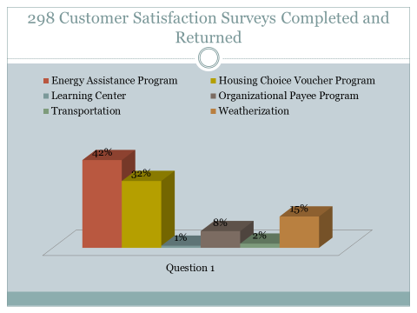

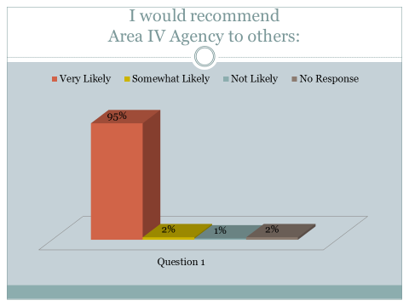

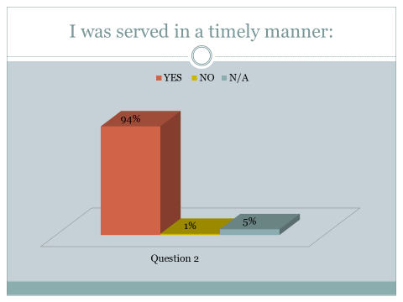

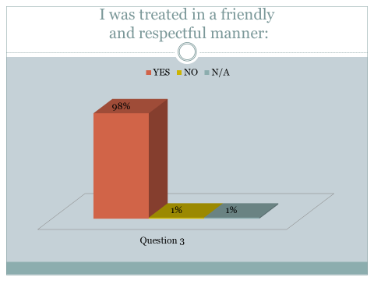

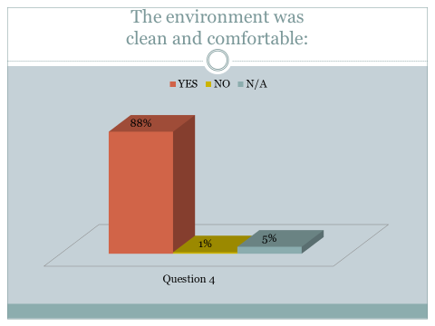

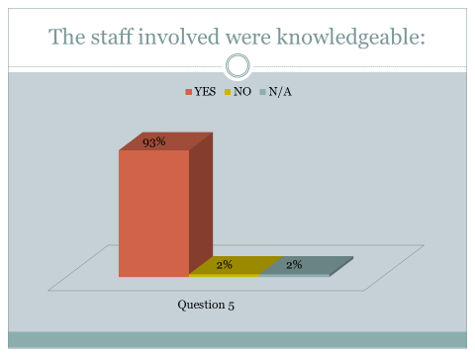

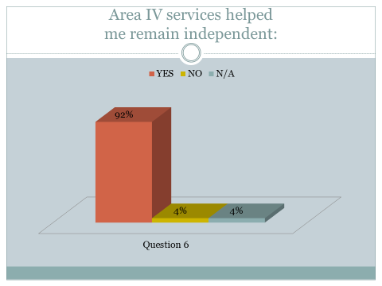

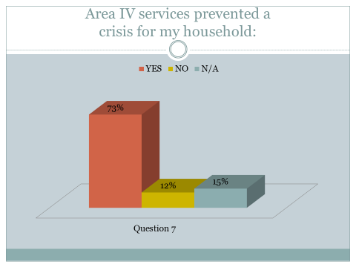

AGING CLIENT SATISFACTION SURVEY RESULTS
Chart 12
Aging Client Satisfaction Survey Results

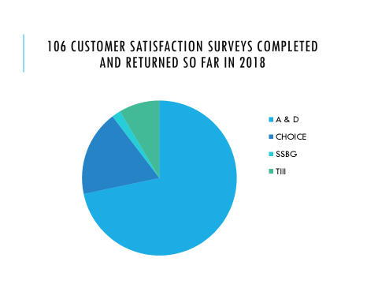

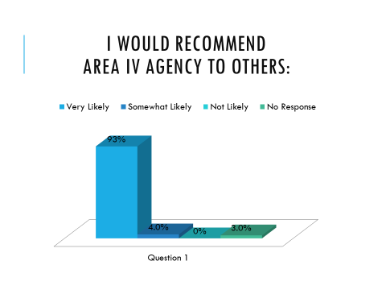

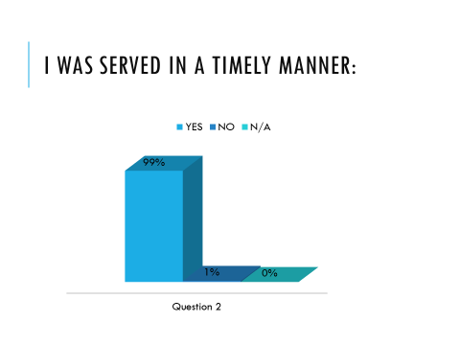

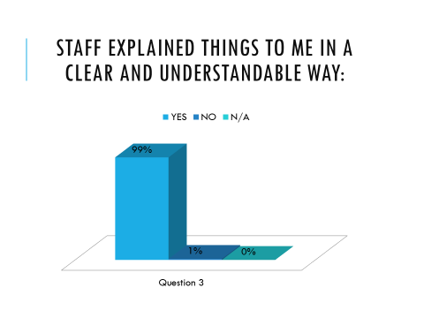
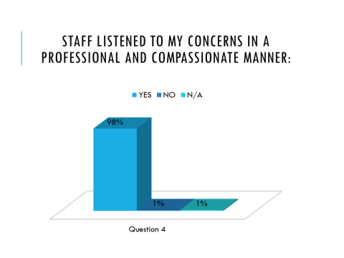

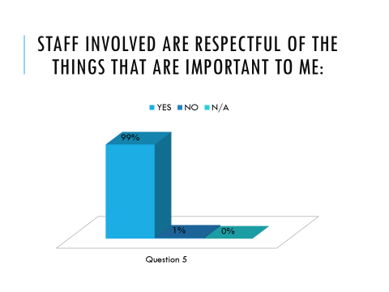
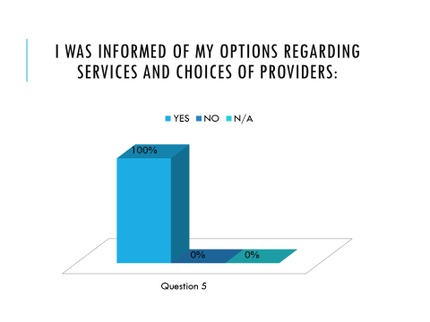

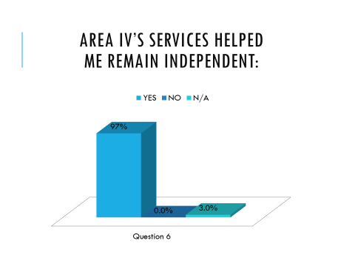
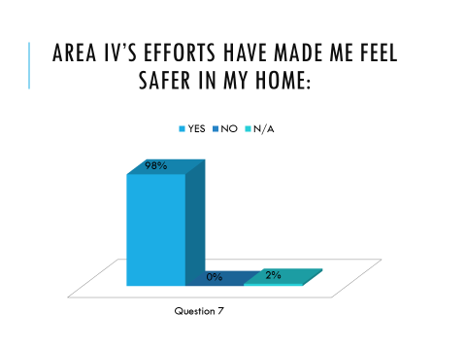

Key Findings:

- Response time needs to be improved in some cases.
- Provider choices need to be made very clear to all clients.
- Customer service training needs to be provided to ensure quality assistance is provided.
Recommendations:

- Supervisors are monitoring timeliness even more effectively by use of checklists and supervision meetings.
- Staff members are providing clients a clear list of provider choices.
- Staff members are being provided customer service training.

